***PHARMACY MANAGEMENT SYSTEM***

**USER MANUAL**

**GROUP MEMBERS:**

**AKULA VENKATA SAI ADITHYA**

**B200820CS**

**KARNAM HEMA BHARGAVI**

**B200776CS**

**MAMIDIPALLI RISHITA**

**B200778CS**

Choose whether you are a customer or an empoyee

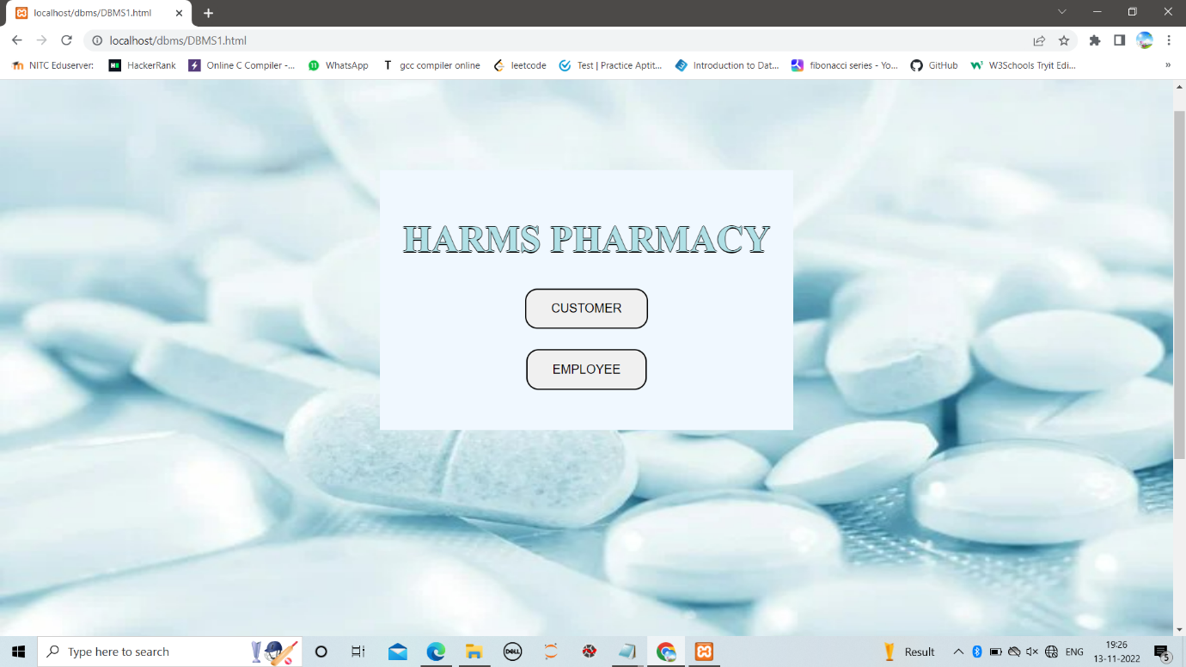

If we choose customer it takes you to the page where you can search for a medicine from your nearest store

**CUSTOMER:-**



Here you can enter medicine name and choose location(Mumbai,Delhi,

Chennai) Then you can find following details of the medicine

Here we entered lisinopril medicine as name it shows following details

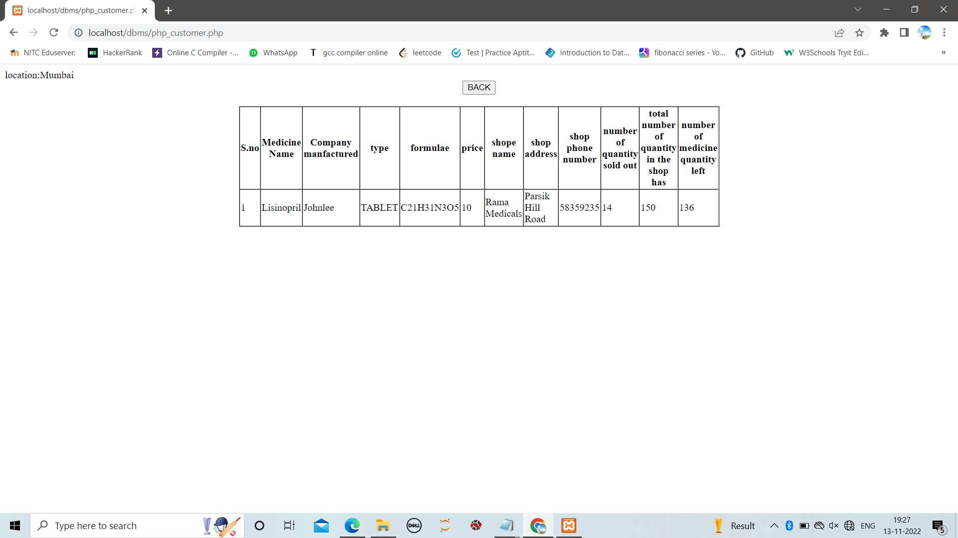

By clicking back you can go to customer page again

**EMPLOYEE:-**

If we click employee button it will open employee login page.

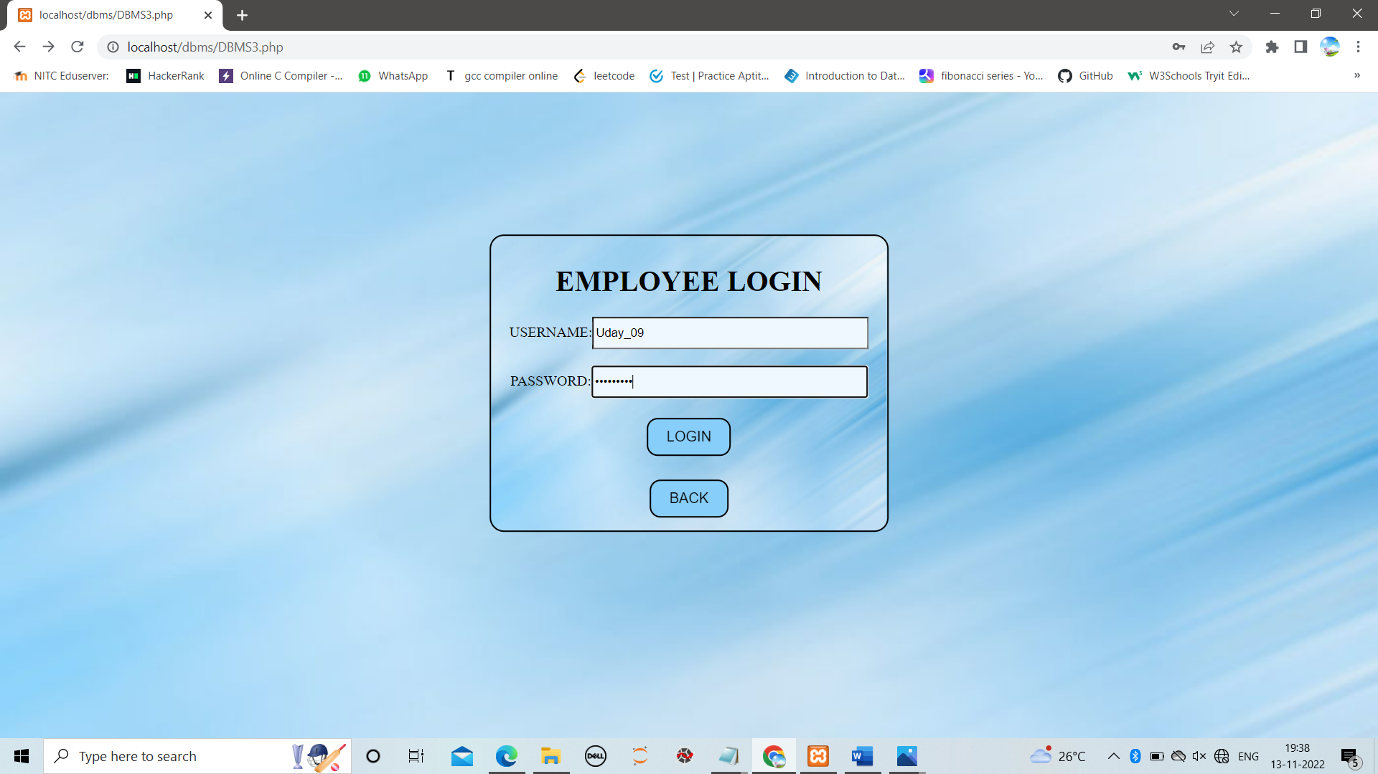

This page will open pharmacist page if given credentials are related to pharmacist or if given credentials are of manager it opens manager work page.

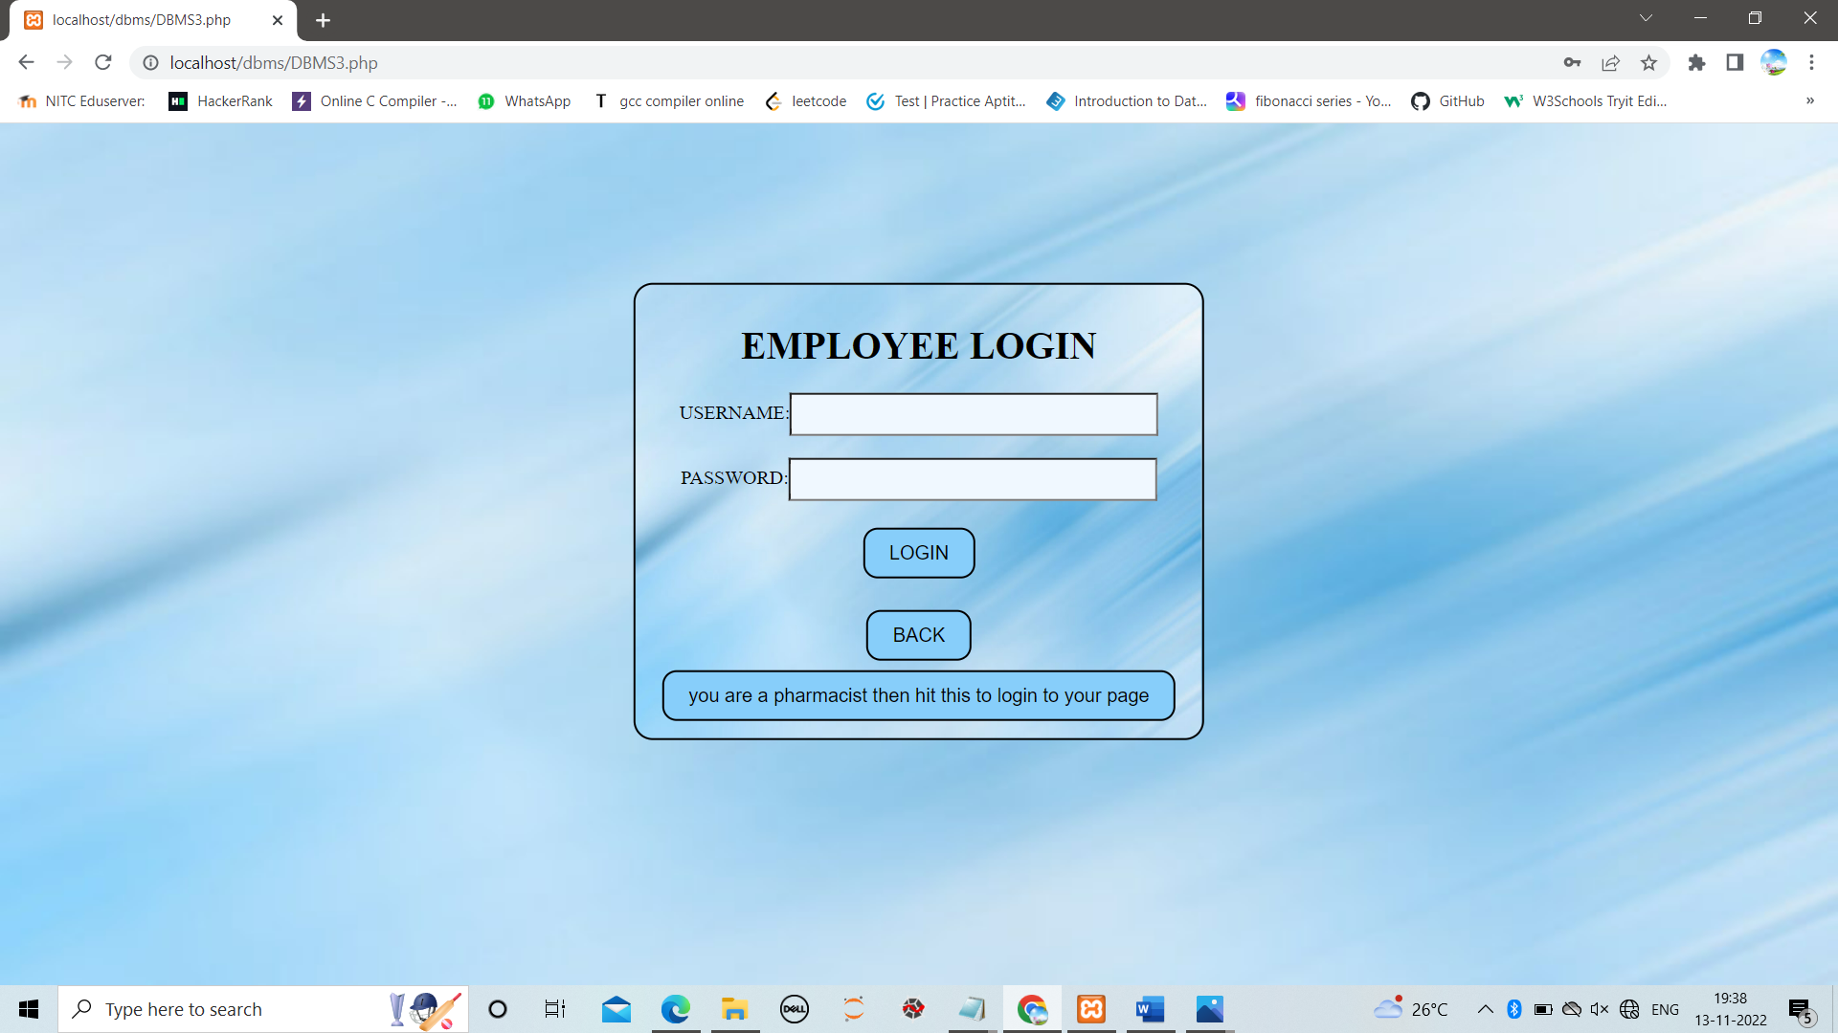

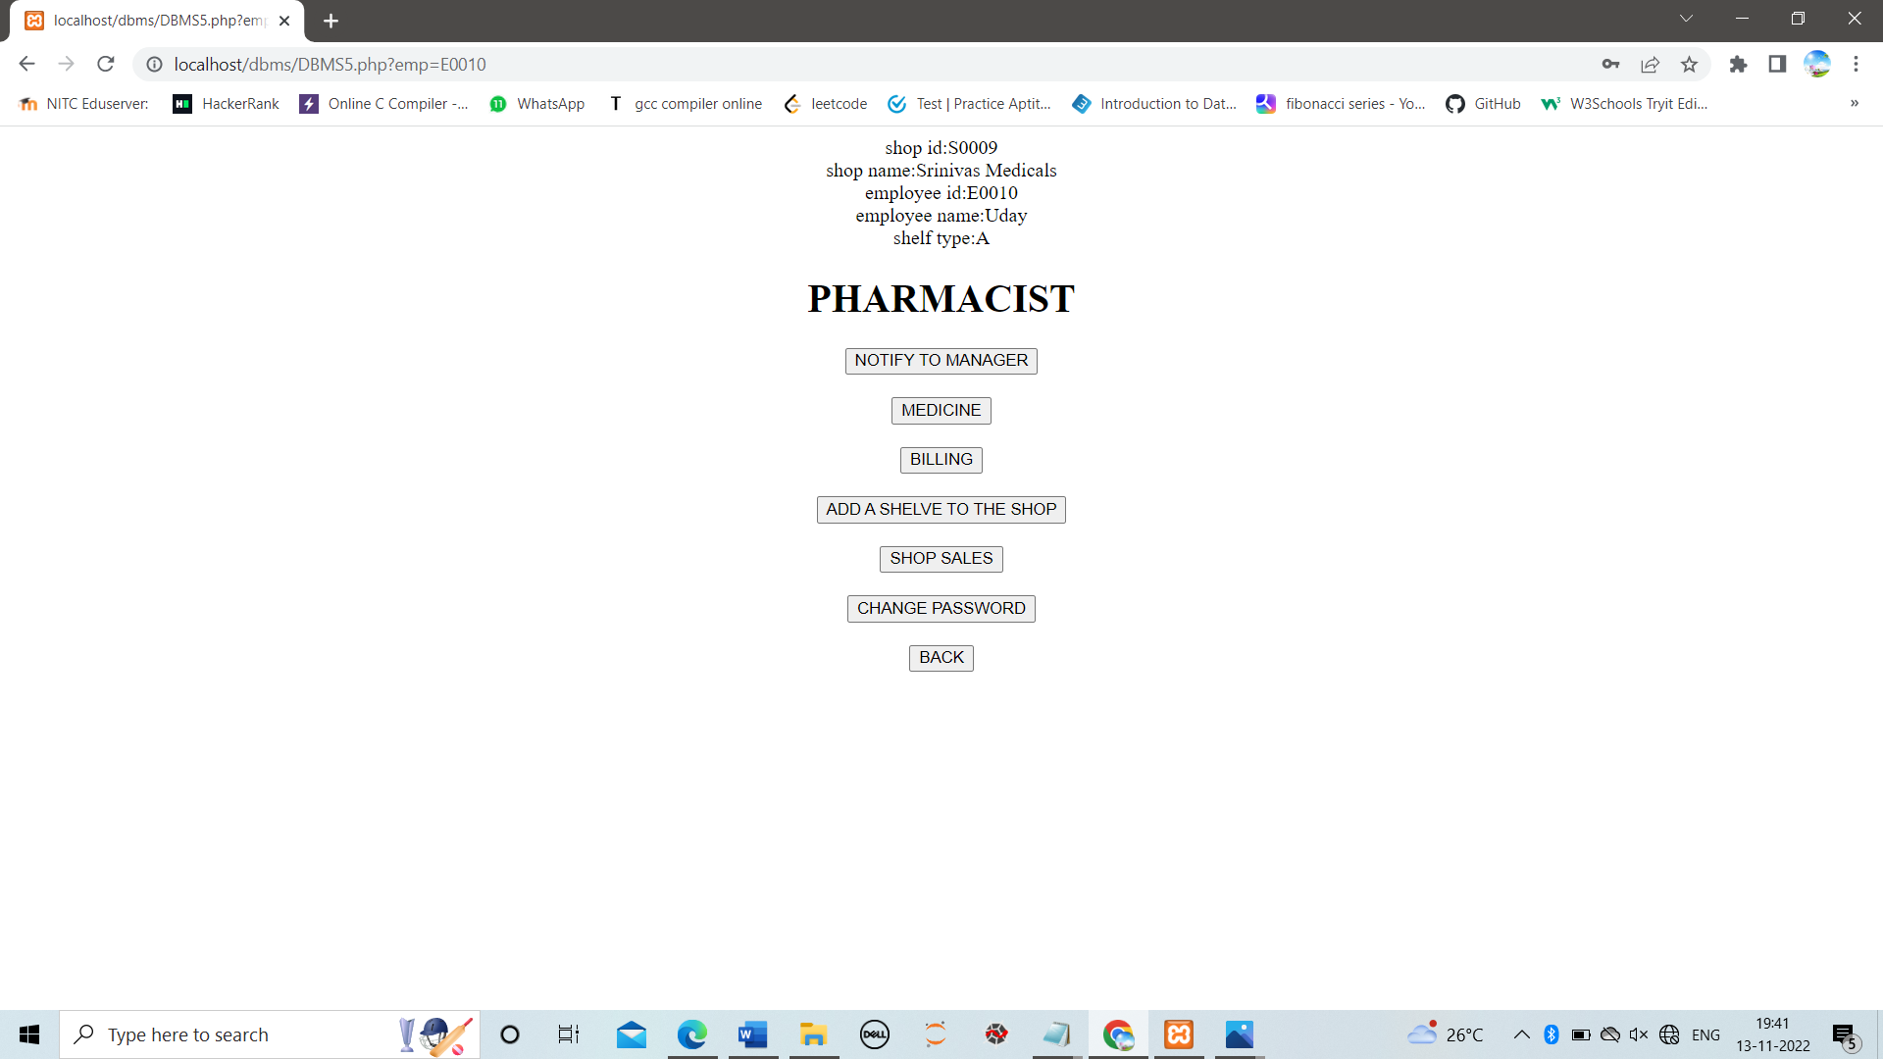

Here we gave pharmacist credentials so it opened pharmacist page with his works along with the working details like shopid,shopname,employee id,employee name,shelf type

**WORKS DONE BY PHARMACIST:-**

**1.NOTIFY TO MANAGER:-**

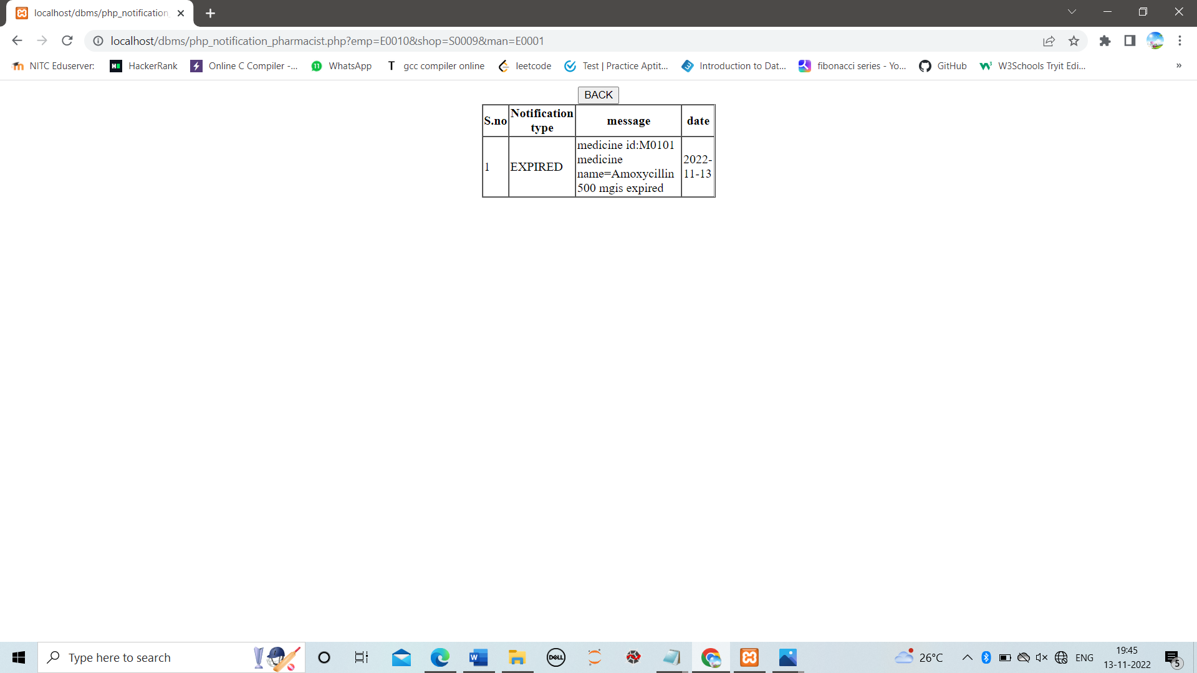

BY clicking this pharmacist notifies manager about expired and low stock medicines in shop.

**2.MEDICINE:-**

Here we entered detais of M0101 Amoxycilin 500mg

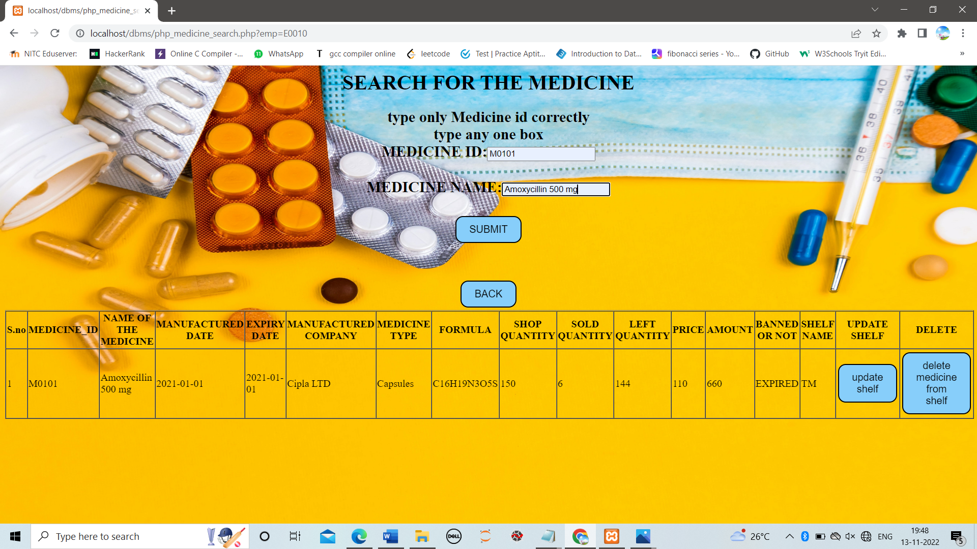

If pharmacist clicks on medicine button in pharmacist page it takes him to search medicine page where he can enter medicine id and name and click on submit to see its details along with shelf name

if it is present in shelf, from here he can

1.update the shelf of medicine also by clicking on update shelf i.e, He can change it from one shelf to another

2.delete the medicine from shelves i.e, He can store somewhere without keeping on shelves.

NOTE:-

If medicine is not in any shelf it will not show delete medicine from shelf button.

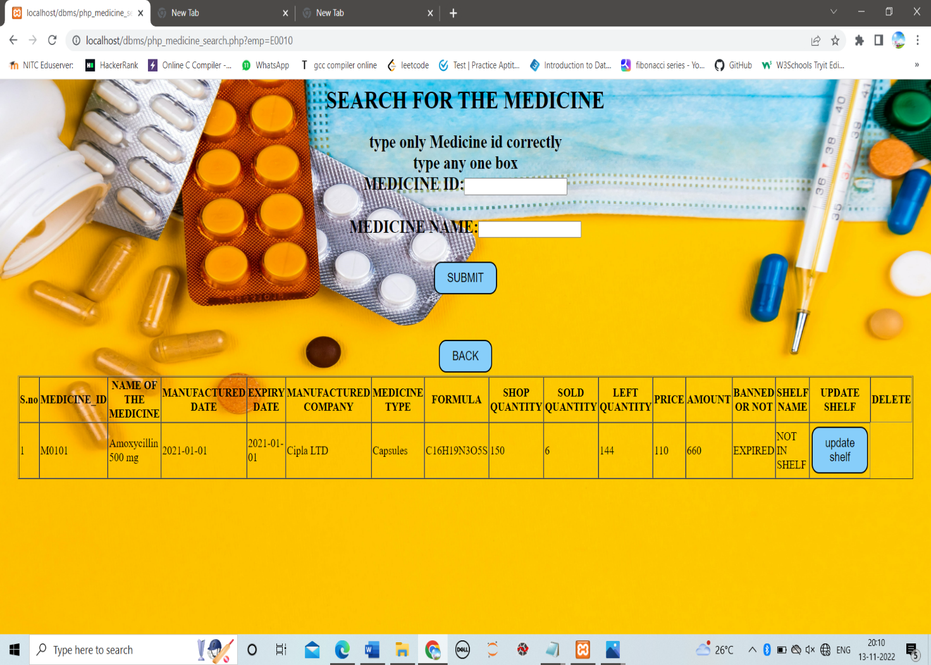

**3.UPDATING SHELF:-**

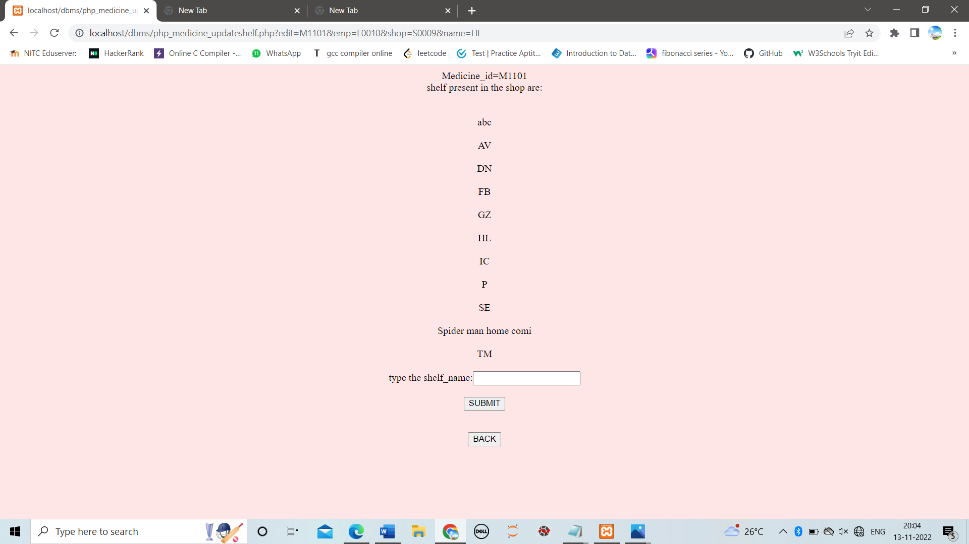

It takes the medicine Id from the above search medicine page and displays and

displays all the shelf types present in shop

Here we can change medicine from one shelf to another or we can allocate a new shelf to a medicine.

**DELETE MEDICINE FROM SHELF:-**

It will delete the medicine from displayed shelf.

**4.BILLING:-**

**i.ADD TO BILL:-**

When we enter medicine id and required quantity it generates the bill details along with bill id,total price and detais of that medicine

Here we entered medicine id as M1601 and qunatity as 4

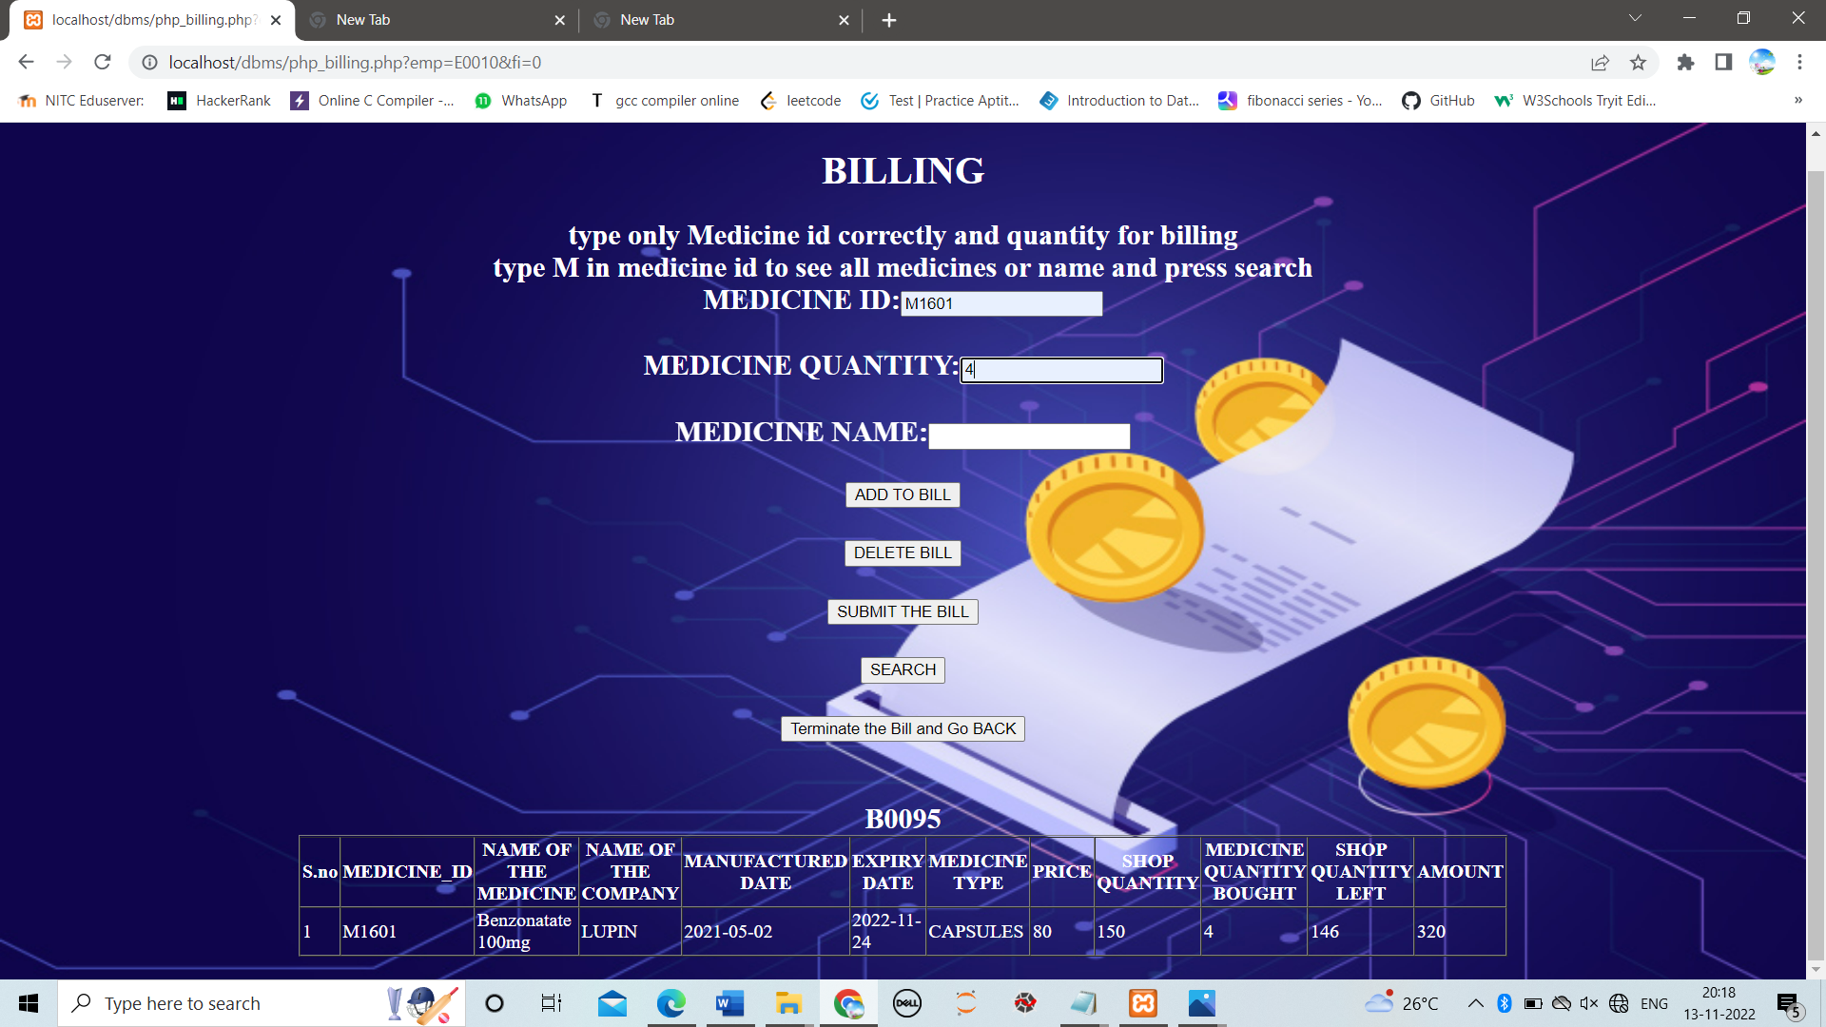

**ii.SEARCH:-**

If we click search here it will display details like how much quantity bought and

the quantity remained in the shop

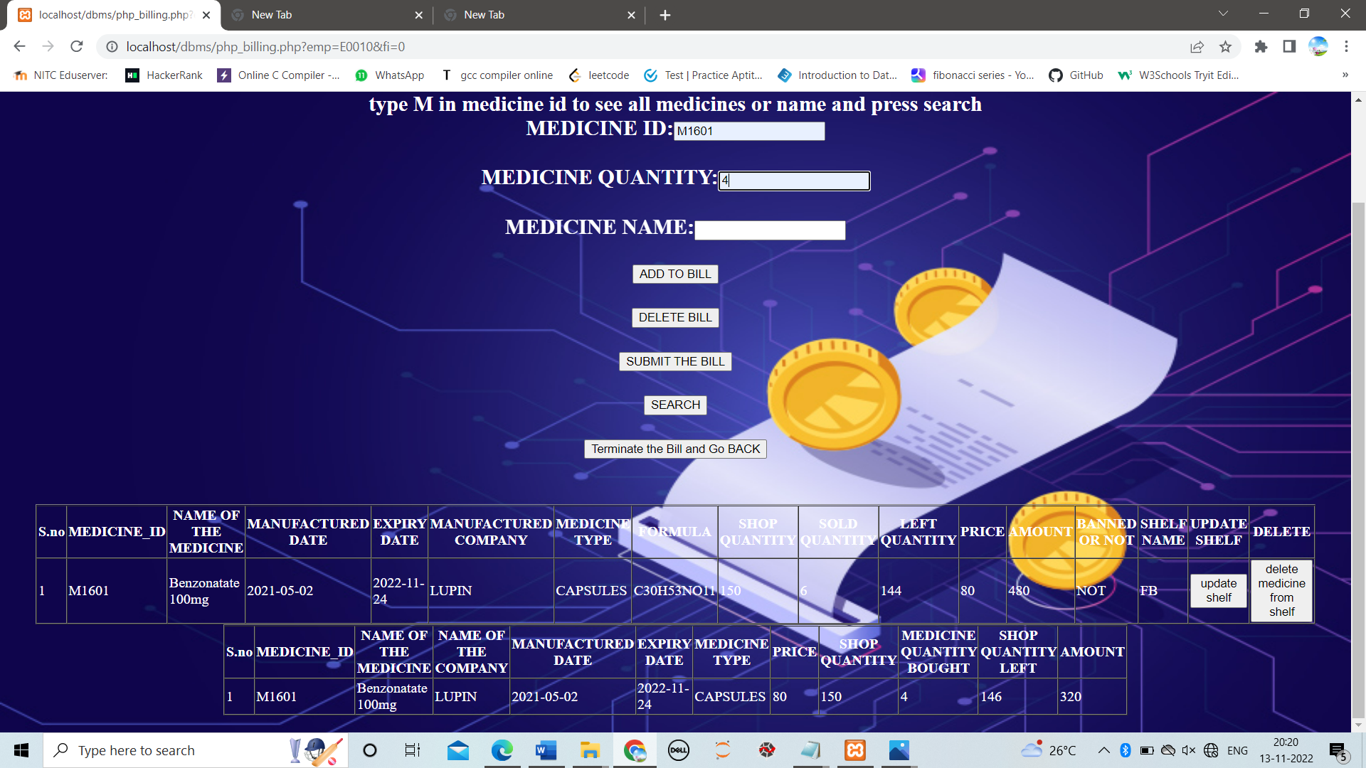

**iii.DELETE BILL:-**

If more than one medicine is present in bill

It deletes entered medicine from the bill(bill id) generated after clicking add to bill

If only one medicine is in the bill

It deletes entire bill

**iv.SUBMIT THE BILL:-**

After entering all the required medicines and quantity we have to click on add to bill for each entry.

After that if we click “submit the bill” button it takes you to customer page where we need to submit detais of customer then it generate a clear bill report with total amount we have to pay.

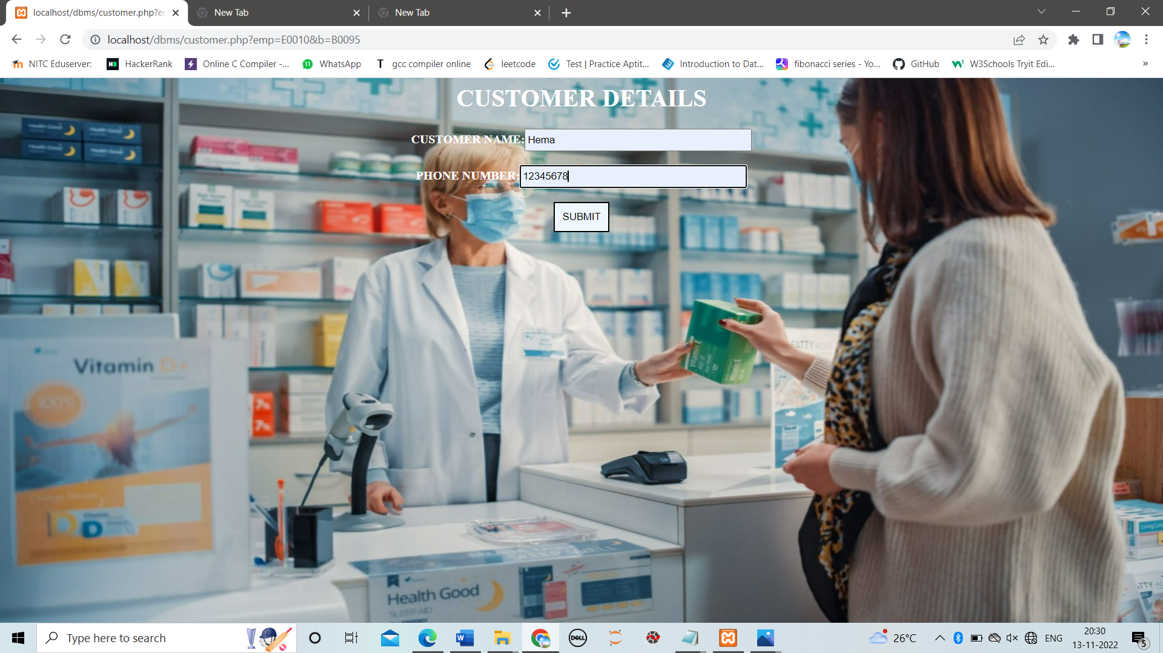

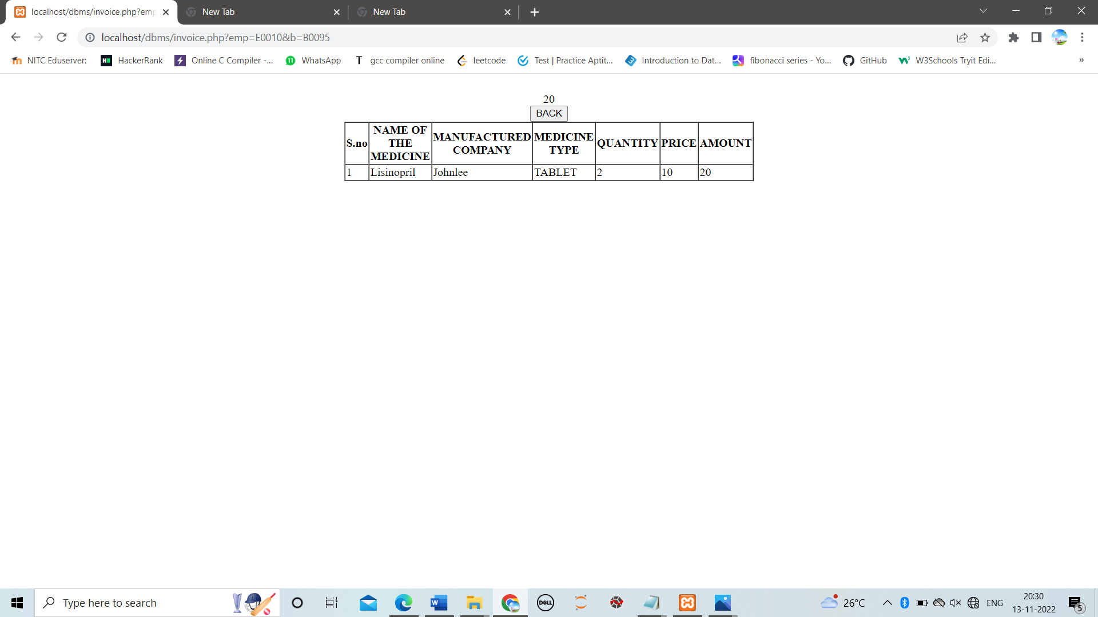

**V.TERMINATE BILL and GO BACK:-**

It terminates bill and takes you back to pharmacist page.

**4.ADDING SHELF TO SHOP:-**

This page adds to new shelf to shop

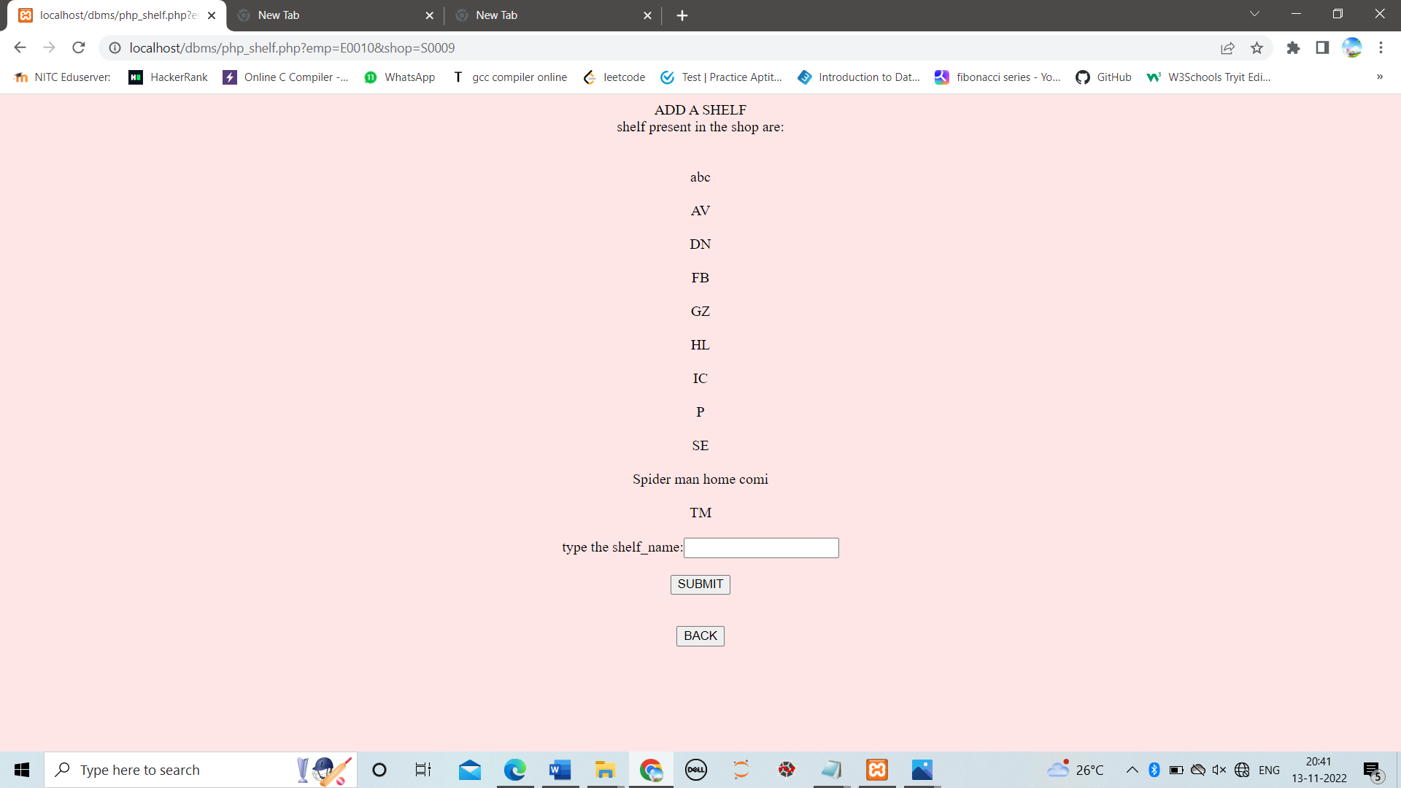

**5.GENERATE REPORT:-**

After clicking this it will generate entire report on quantity of medicine sold,unsold etc of the particular shop in which pharmacist works.

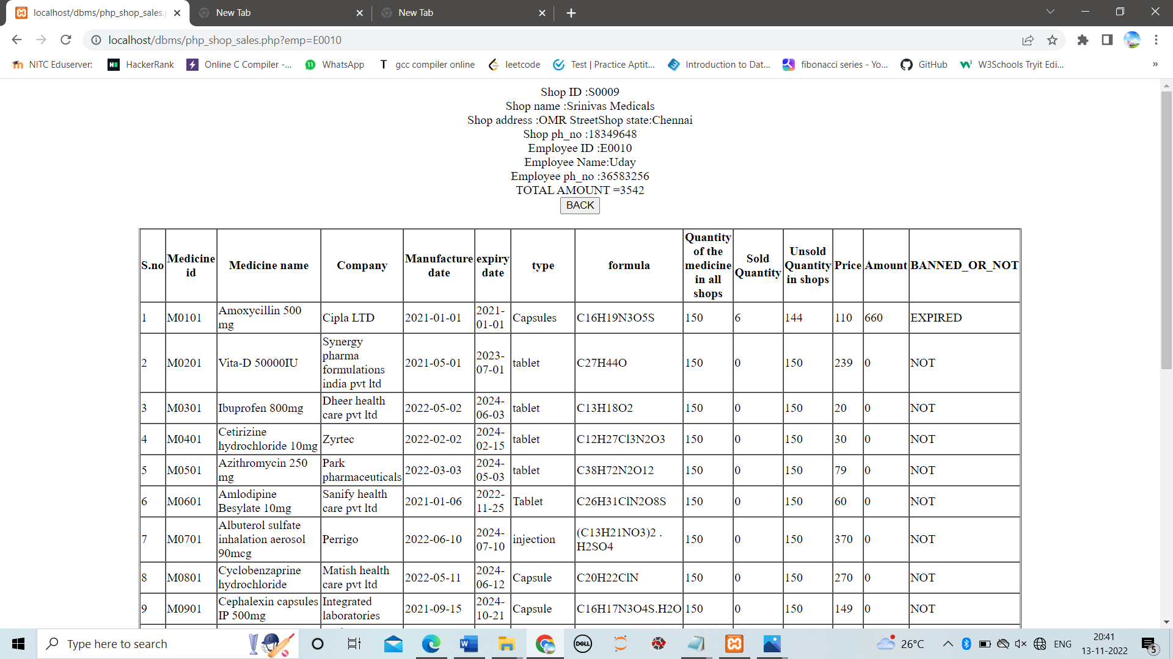

**6.EMPLOYEE CHANGE LOGIN:-**

Pharmacist can change his login crendentials from this page

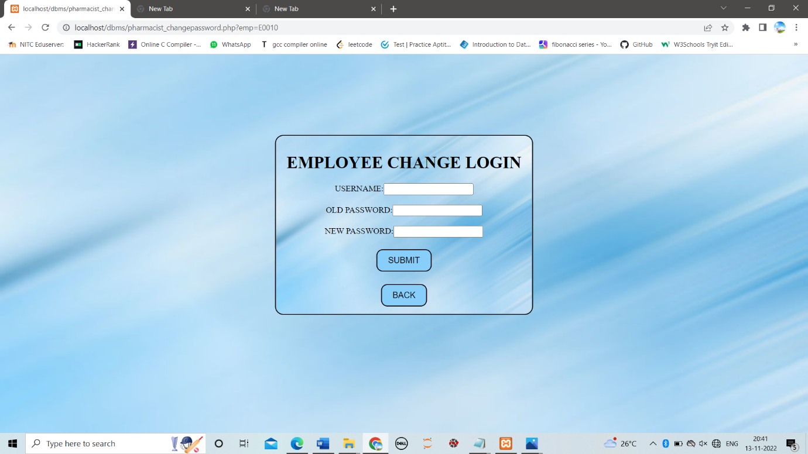

**MANAGER:-**

IF EMPLOYEE LOGIN CREDENTIALS MATCH TO MANAGER

Then Manager page will appear

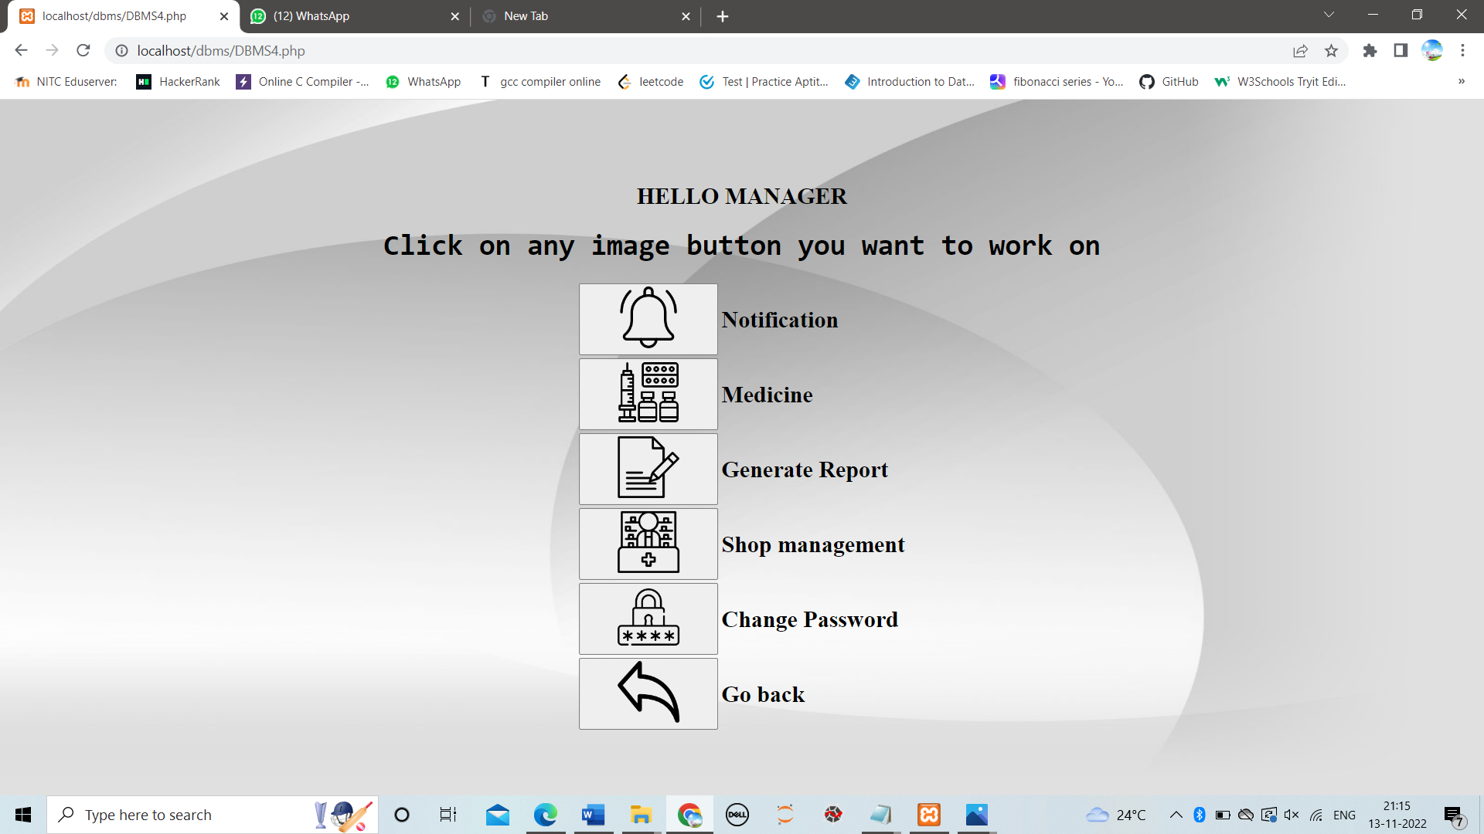

**1. NOTIFICATION:-**

Generates a entire report of expired medicines and low stock medicines submitted by every pharmacist in pharmacist page.

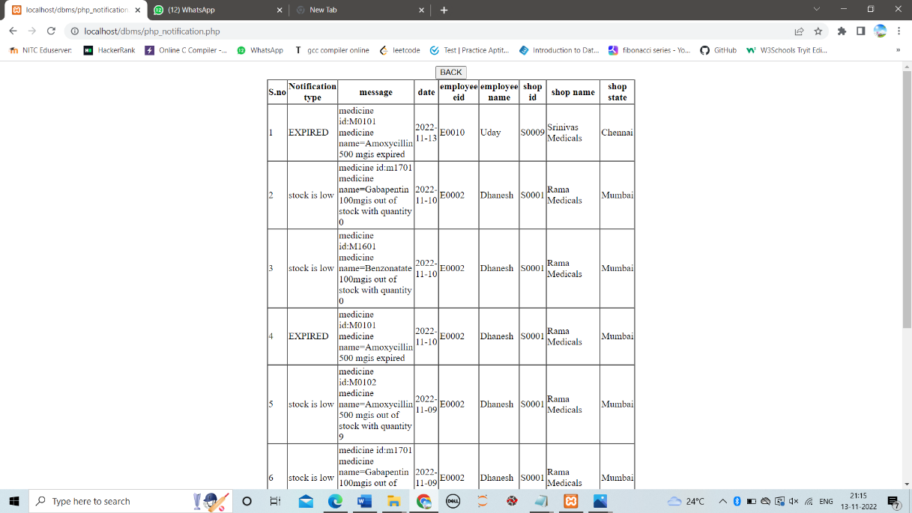

**2.MEDICINE:-**

We can add a medicine and manipulate a medicine from this web page.

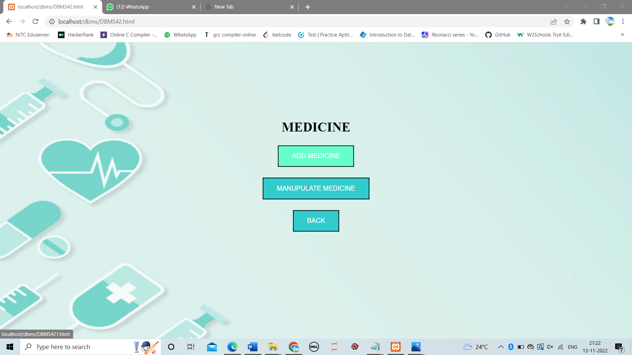

**i.ADD MEDICINE:-**

it adds a new medicine to database

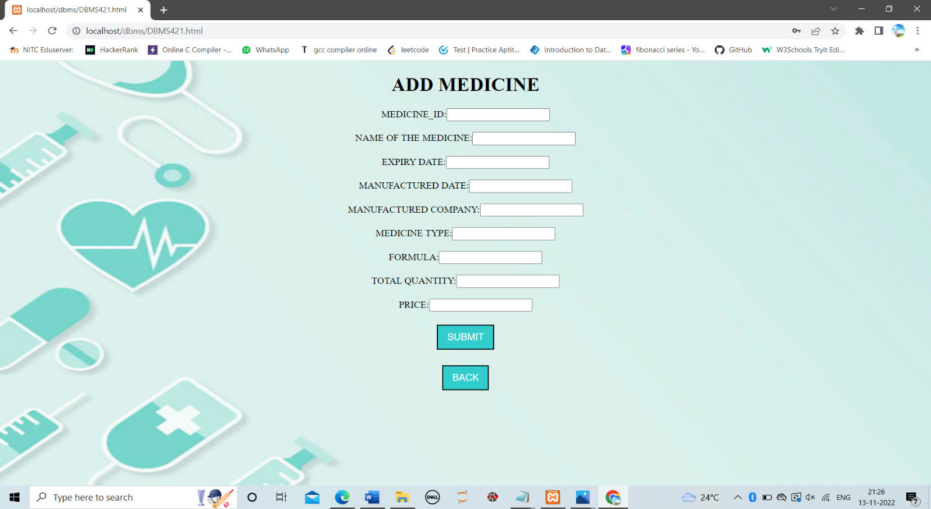

**ii.MANIPULATE MEDICINE:-**

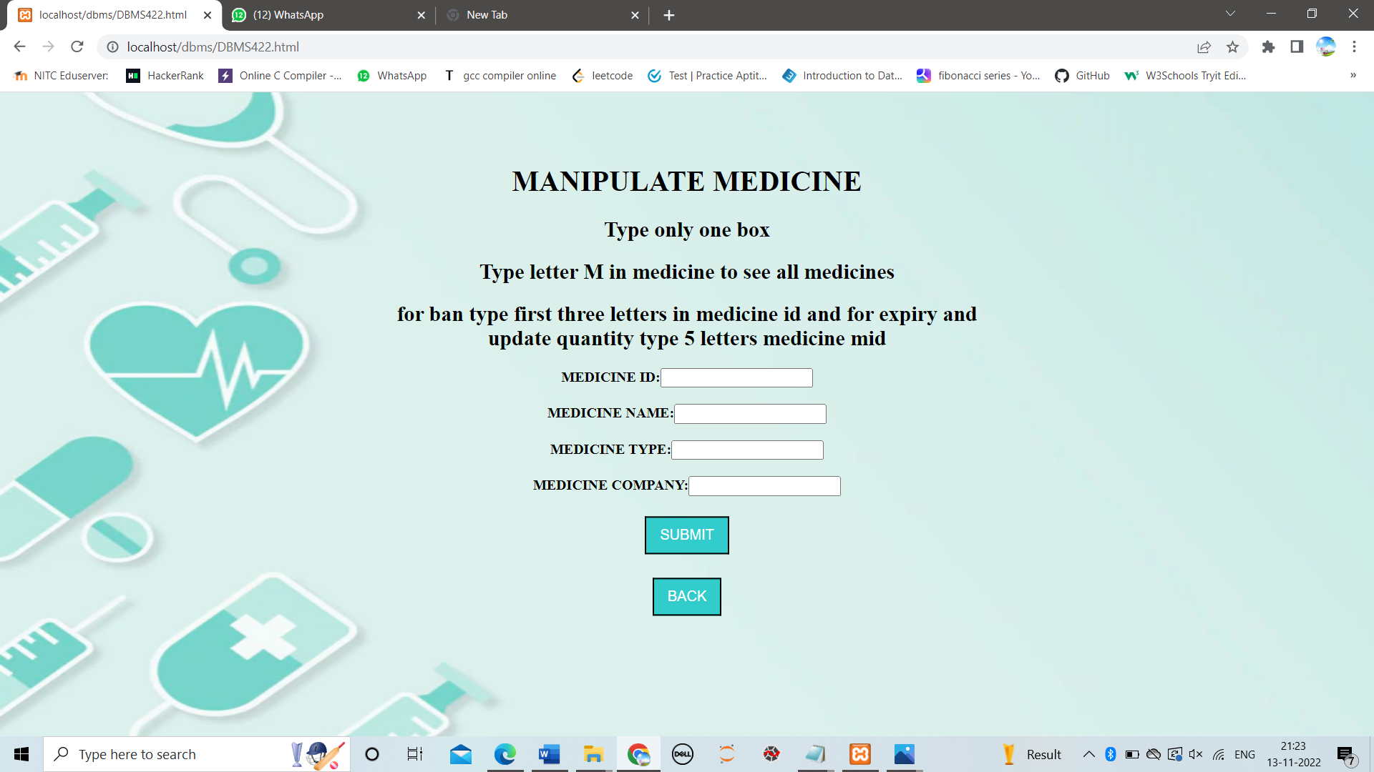

a)If we type M in medicine id we will get details of all medicines present

b)If we type first 3 letters of Medicine id we can add that particular to banned or expired medicies list

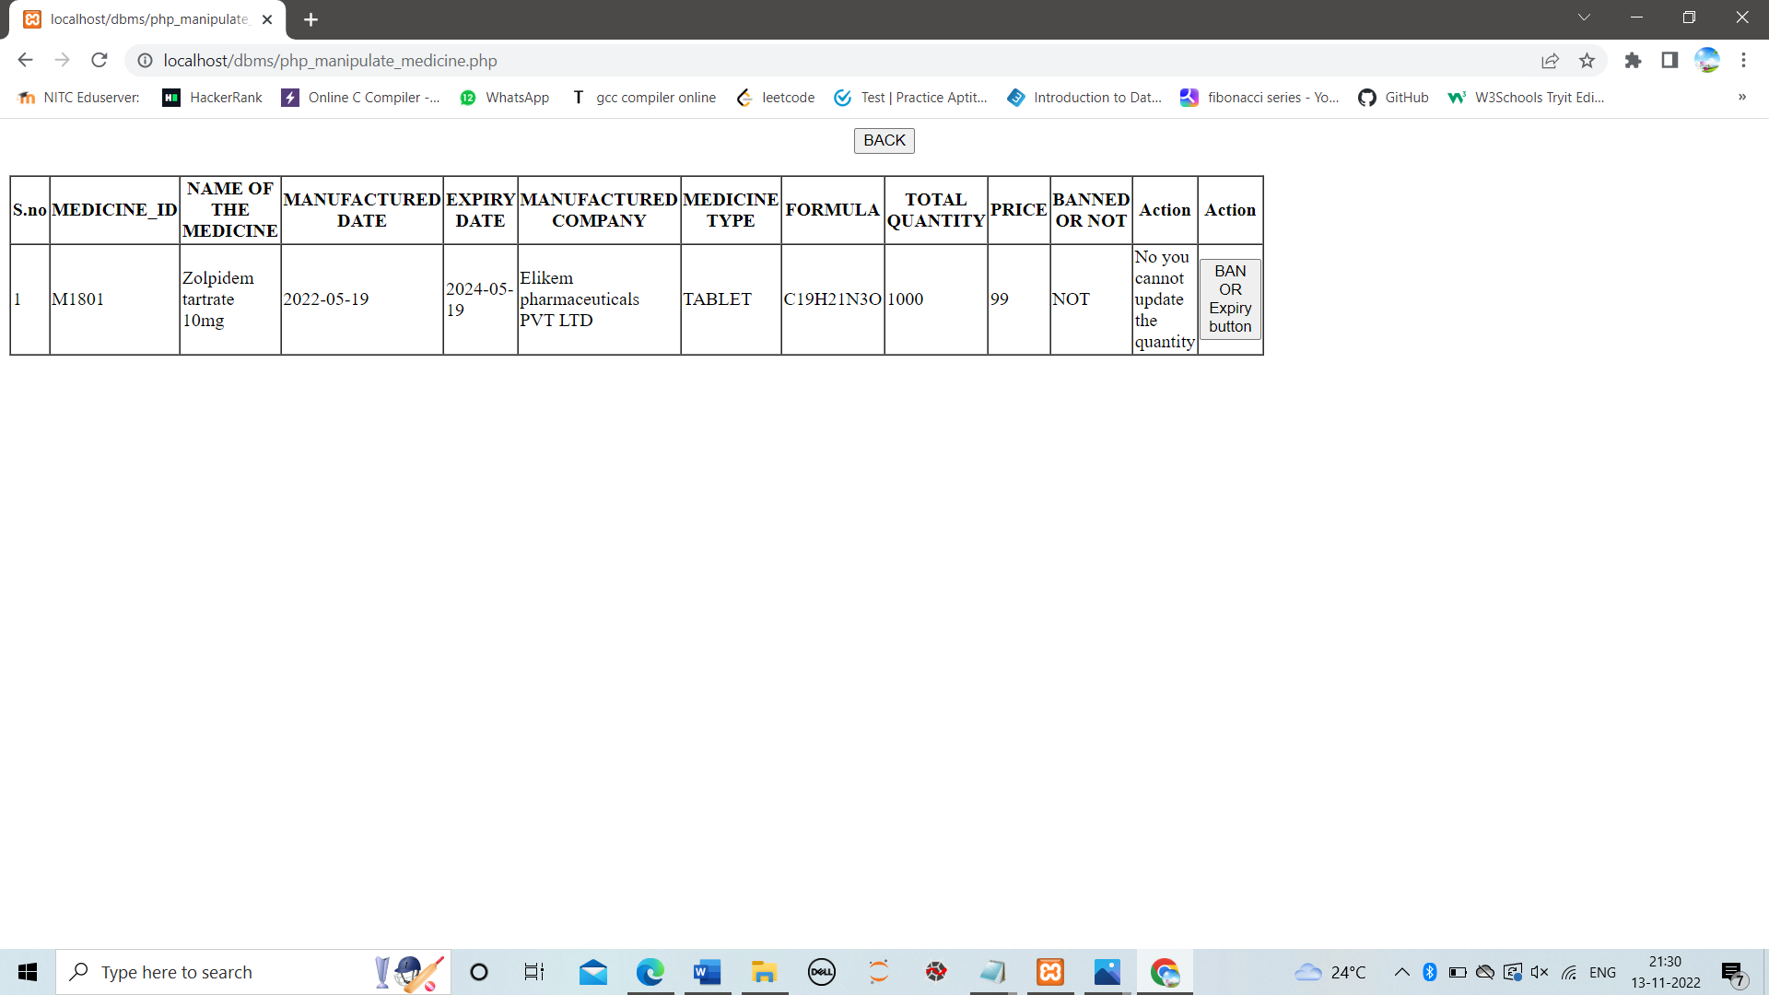

If we click ban or expiry button then we can add that particular to banned or expired medicies list

c)If we type full medicine id or entire detais of medicine it show update button also

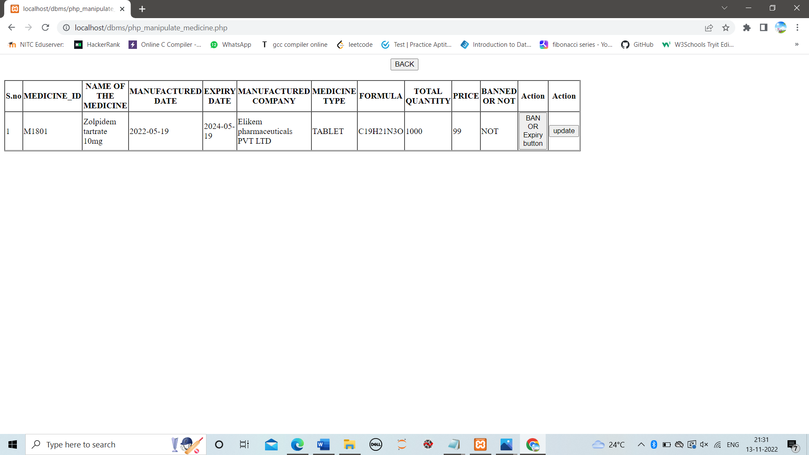

If we click the update button then we can update the detals of that particular medicine

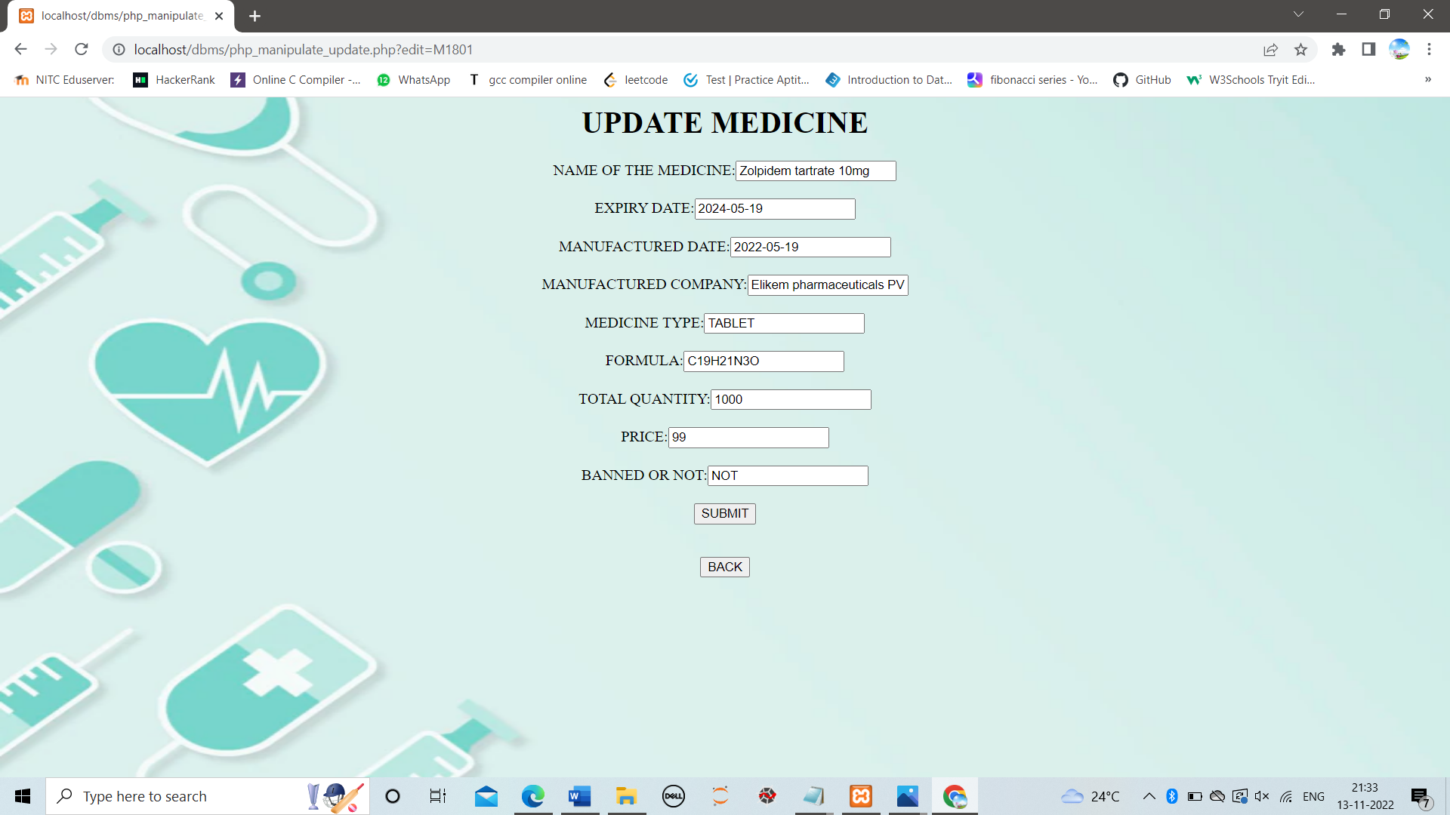

**3 GENERATE REPORT:-**

It generates the details of the medicines with following details

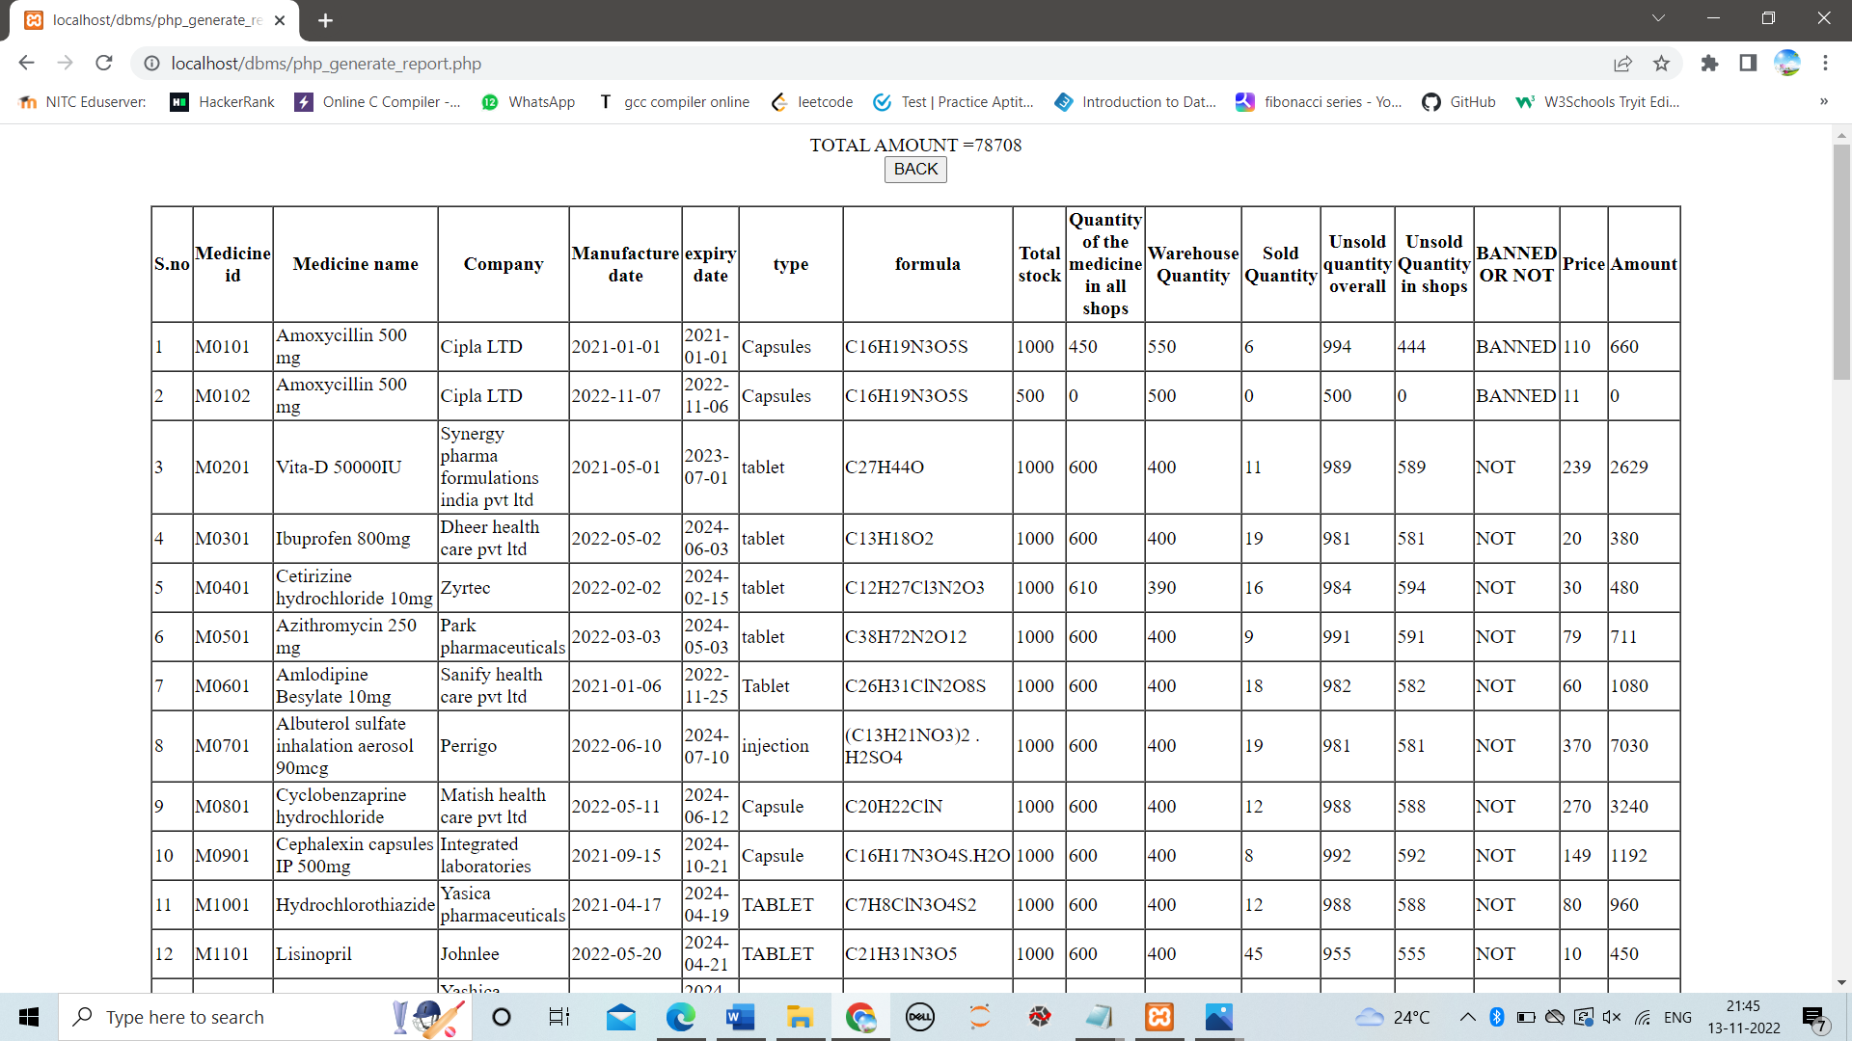

**4 SHOP MANAGEMENT:-**

In shop management we can add quantities for a nw/old medicine and we can get shop reports



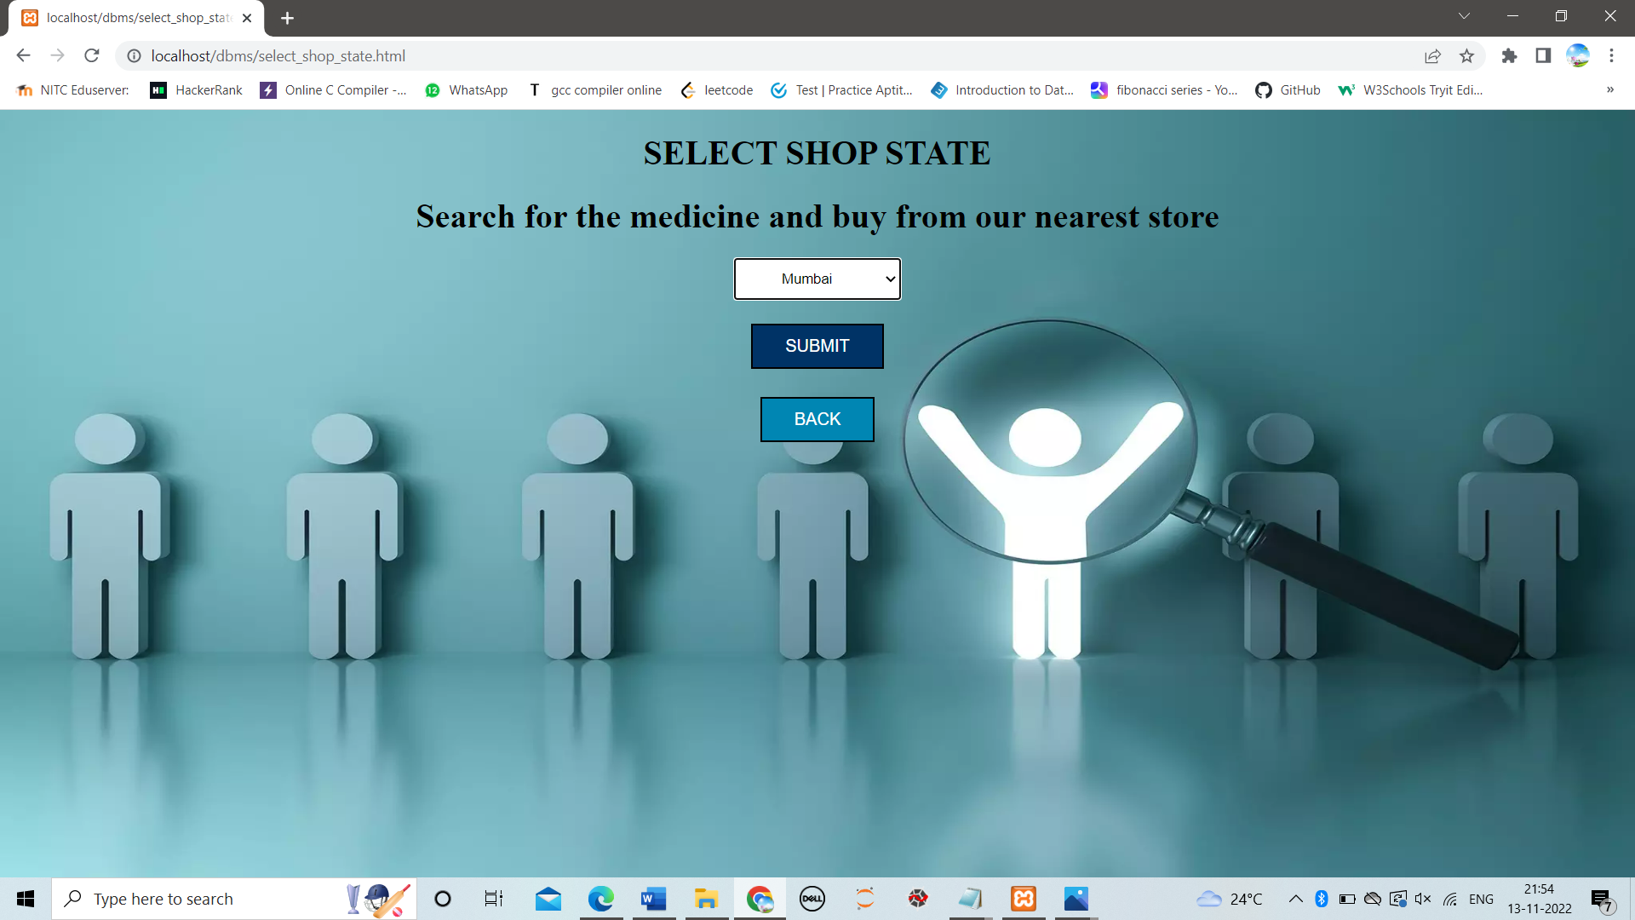

By choosing a state(mumbai,chennai,bangalore) we can get details of medical stores details in that area.

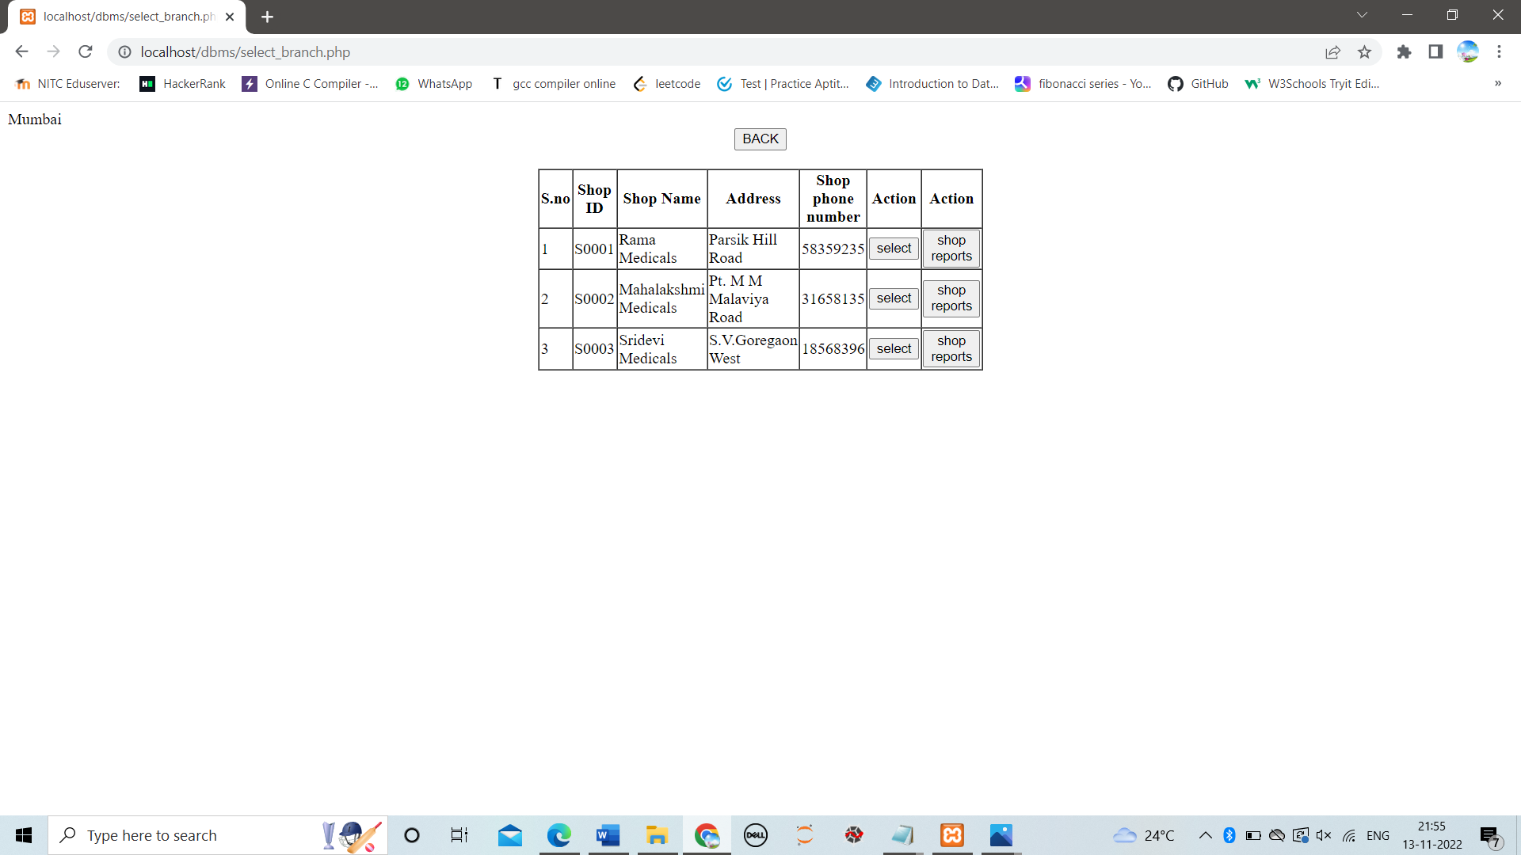

If we want to add medicine quantity to shop

Click on select the takes you to following page

Here we can check the quantity of medicine like shop quantity,sold quantity,left quantity in shop

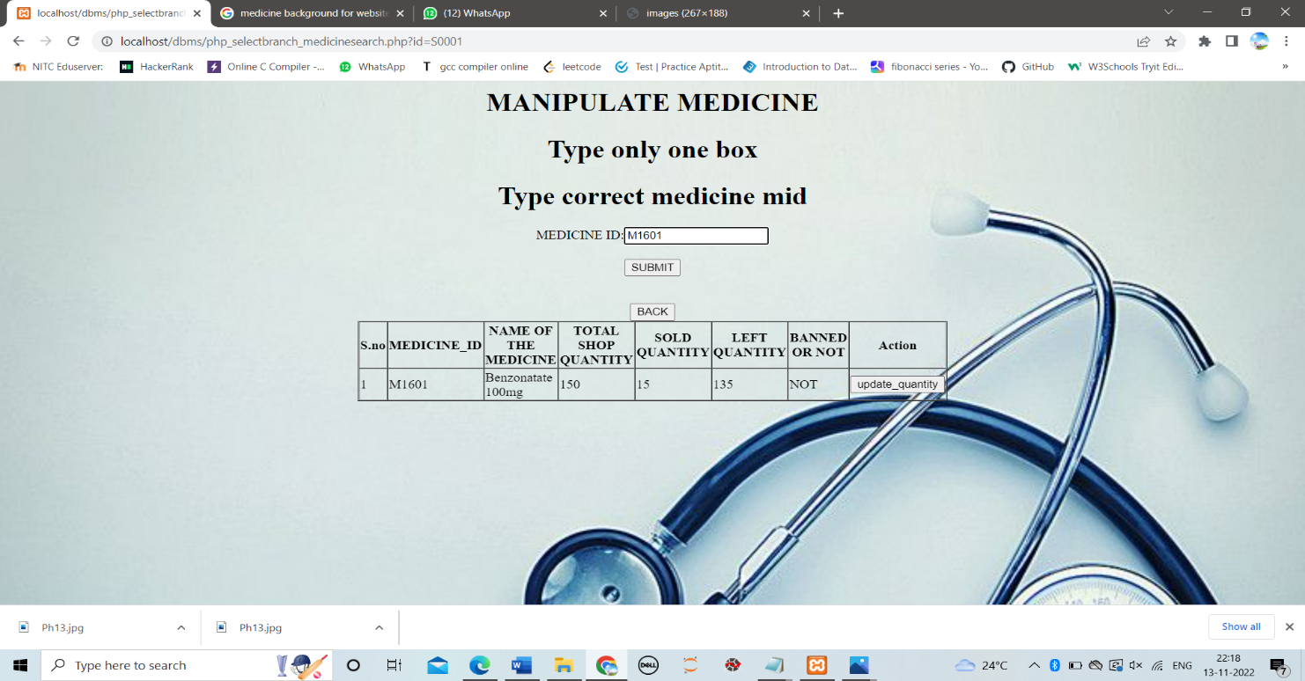

If we want to add quantity we can click on update quantity

NOTE:-we can add a new medicine also here

If we enter a new medicine id it shows zero quantity then we can add quantity by clicking update_quantity button

If quantity of medicine is zero and we entered a negative value in extra quantity to be added it will delete the medicine from database.

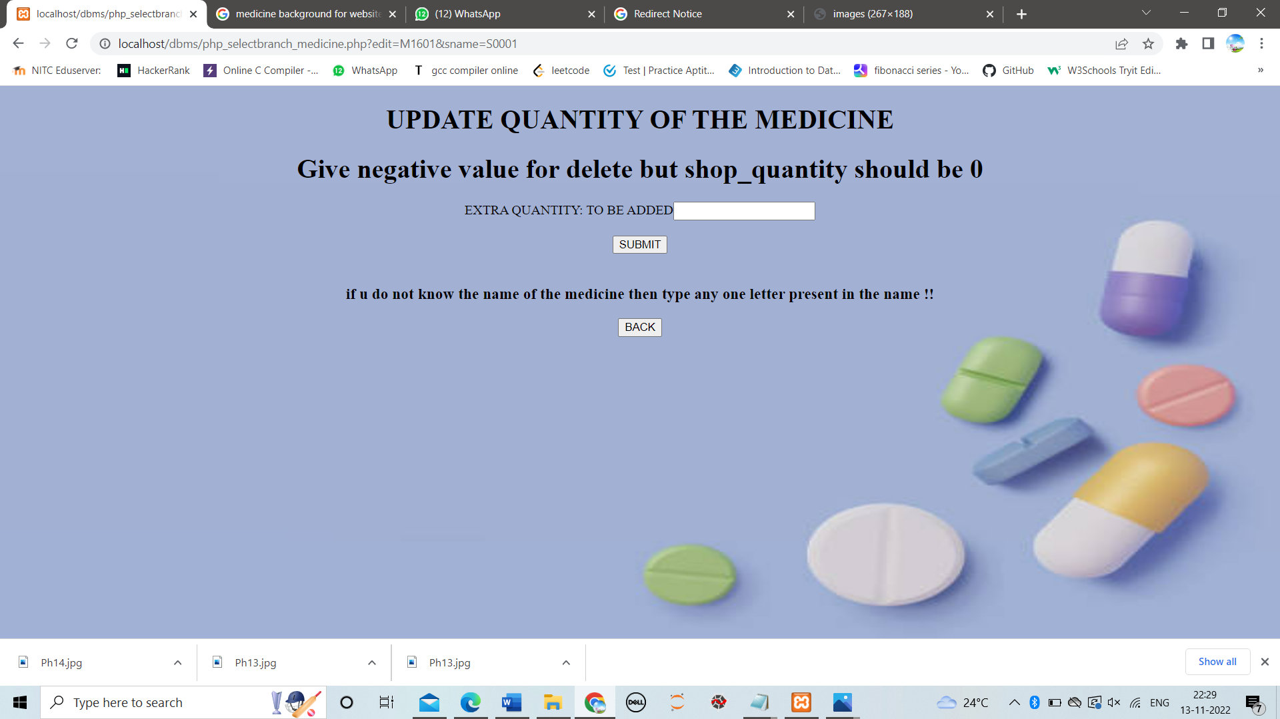

From here we can generate shop report of medicines on following details by clicking shop reports

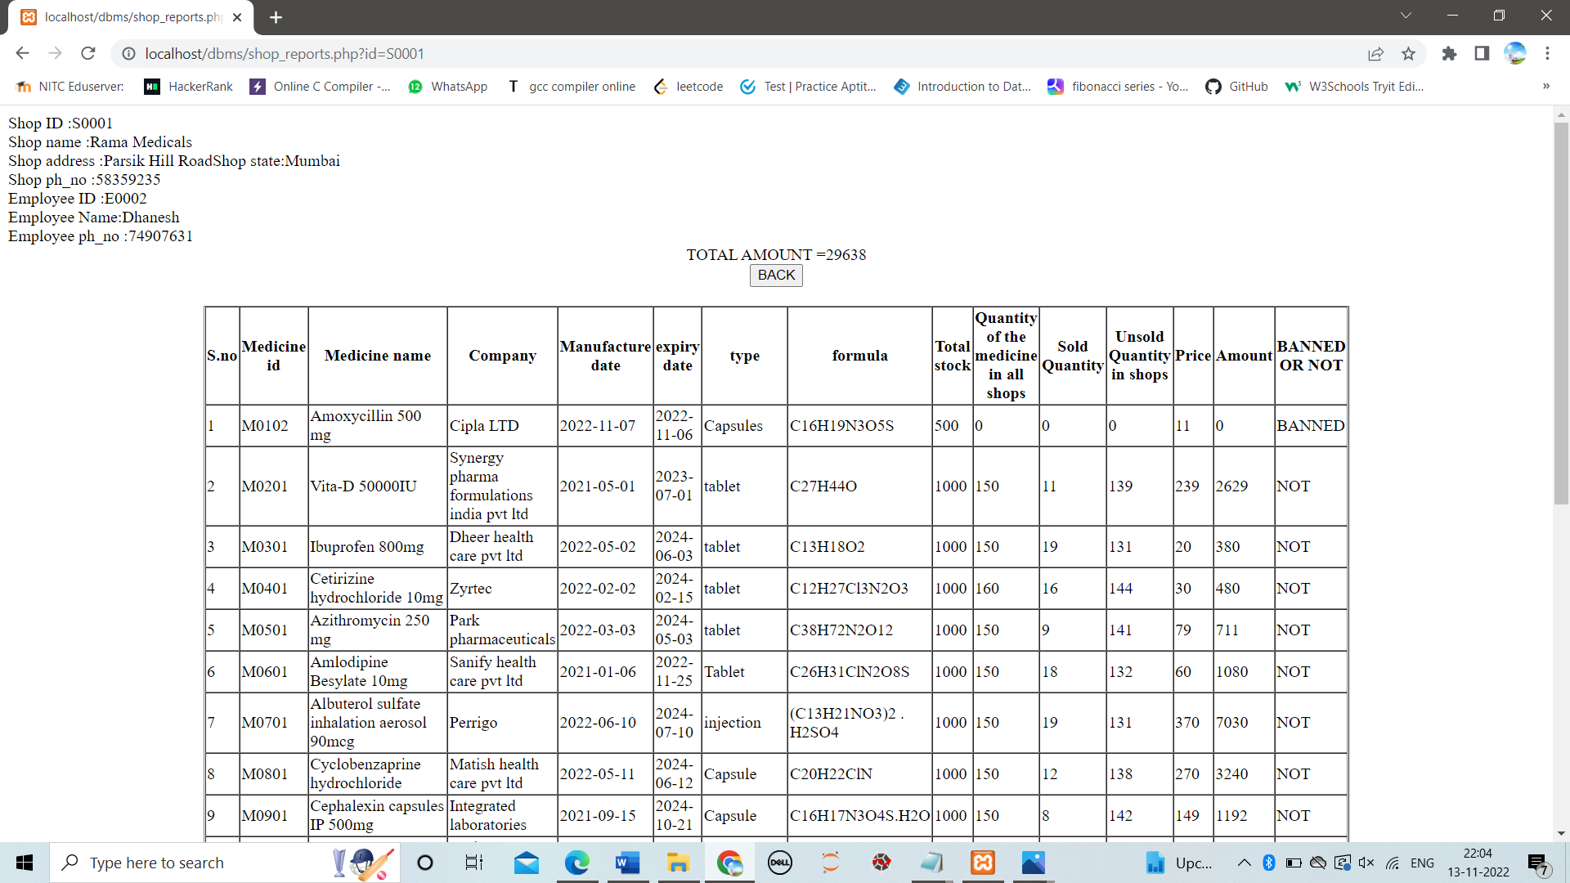

**5 CHANGE PASSWORD:-**

Here manager can change his login credintials

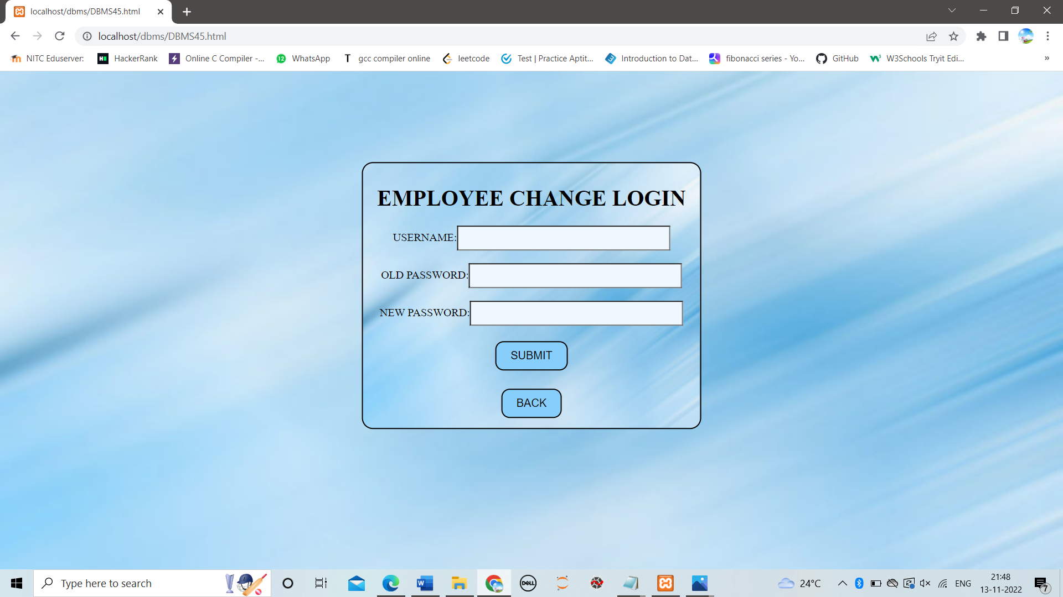

**6 GO BACK:-**

Here go back button will direct us to employee login page at the begining